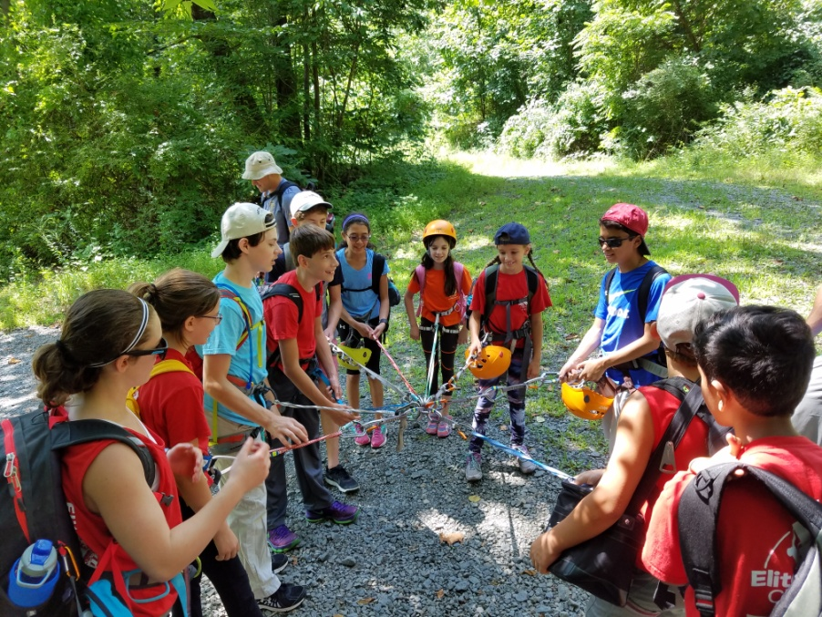

Summer Camp Registration Form

Please mail or bring your completed registration to

Elite Climbing, 67 Old Kings Highway, Maple Shade, NJ 08052

Please Print

CAMPER INFORMATION:

Camper’s Name _______

Date of Birth / /

Age

Male Female

Address: Apt. No.

City/State/Zip Home Phone

PARENT/GUARDIAN INFORMATION:

Parent/Guardian Name Parent/Guardian Name

Email___________________________ Email____________________________

Business Phone Business Phone

Cell Phone Cell Phone ______

EMERGENCY CONTACT INFORMATION:

**In Emergency Notify Relationship

Phone Cell Phone

At 4:00 p.m. Dismissal or at end of extended day, My Child Will:

Picked up by parent Picked up by someone other than parent

**Individuals AUTHORIZED to pick-up your child MUST be listed and MUST have proper photo I.D. when picking-up your child. All individuals must be 18 years of age or older.

Please provide the names and phone numbers of individuals AUTHORIZED to pick your child up from camp or use as an emergency contact.

1. Name Phone

Relationship Cell Phone

2. Name Phone

Relationship Cell Phone

During each week of summer camp we will be taking the kids on an outdoor climbing trip. This trip is included in the full week payment, half day campers may join the trip for an additional fee. Parents are invited to participate/chaperone as well.

Please check the circles below to indicate the session for which you are registering your child(ren). Please specify.

Summer Camp

July 17, 2017 through July 21, 2017 8:00 am – 4:00 pm

July 24, 2017 through July 28, 2017 8:00 am – 4:00 pm

August 14, 2017 through August 18, 2017 8:00 am – 4:00 pm

August 21, 2017 through August 25, 2017 8:00 am – 4:00 pm

August 28, 2017 through September 1, 2017 8:00 am – 4:00 pm

Summer Camp Fees: Extended Day Options

$275 per week/per child 7:30 am drop off time - $10.00 extra per day per child

$155 per week- half days/per child 5:30 pm pick up time - $10.00 extra per day per child

$60 per full day/per child

$35 per half day/per child

Full Five Week Summer Camp- July 17, 2017 through September 1, 2017

_____Extended 7:30 am ______Extended 5:30 pm

Four Week Summer Camp- please specify which four weeks your child will be attending:

_____Extended 7:30 am ______Extended 5:30 pm

Three Week Summer Camp- please specify which three weeks your child will be attending:

_____Extended 7:30 am ______Extended 5:30 pm

Two Week Summer Camp – please specify which two weeks your child will be attending:

_____Extended 7:30 am ______Extended 5:30 pm

One Week Summer Camp – please specify which week your child will be attending:

_____Extended 7:30 am ______Extended 5:30 pm

Please specify which weeks your child will be attending here:____________________________

______________________________________________________________________________

PARENT’S AGREEMENT:Please sign below

There is a $100 non-refundable registration fee, which does go towards your camp balance. $100 Deposit required at time of booking. We require a 30 day notice to cancel your camp registration and receive a full refund. Failure to provide adequate notice will result in the loss of camp deposit,regardless of the circumstances.Final payment is due no less than a week prior to the first day of camp.Payment accepted in cash, check, or credit cards. If a parent or guardian cancels a session after the 30 day grace period, the deposit for the session(s) is forfeited.

Parent’s Signature Date

Summer Camp Discounts

10% OFF each additional sibling enrolled
10% OFF if paid in full by June 1, 2017
Discounts do not apply to early drop off, late pick up, half day rates, or daily rates.

Credit Card Payment: Please mark one

Type of Card Master Card Visa American Express ___ Discover

Card No.

Name (as it appears on card) Exp. Date

Security Code: ______________________________

For Internal Use Only:

Date of Registration:
Deposit Amount Paid: Method of Payment:
Received By:
Remaining Balance:
Remaining Balance Paid: Received By:

